**Notes on deriving sensitivity of excess generation factor to system sizing**

*See sensitivity_of_excess_gen_to_sizing.R for more detail*

This script calculates the sensitivity of the excess generation factor to relative sizing of annual generation to load. The original calculation assumes that sum(hourly_gen) = sum(hourly_load) for an annual time series. That value is the excess_generation factor. However, how does that value change if the system is smaller or larger?

=> I find that the relationship is roughly linear when generation is bounded by 50% to 115% of annual load. The relationship is excess_gen_factor = 0.31 * (gen/load) + 0.25

=> Another takeaway from this is that even at a small sizing (50%), roughly 40% of energy is still spilled

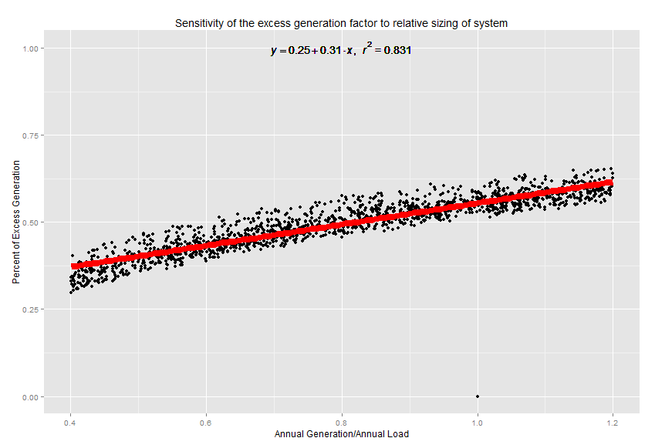

To calculate the sensitivity, I simulate possible load and generation profile 2000 times. For generation profiles I sample from AWS 8760 profiles that we use in the model. For load, I assume a weibull distribution of moment = 1, shape = 1. In each simulation the sum of annual load is scaled randomly from 40% to 120% of sum of annual generation.